

**Software Title: Visual Prediction**

**GROUP MEMBERS:**

**1. Ritesh Choudhary**

**2.Ajay Jangid**

**3.Deep Gandhecha**

**4.Rishab Bhat**

**Guided by: Dr. M.A. Thalor**

**INTRODUCTION**

In recent times, there has been immense research in the machine learning and artificial intelligence field. Resulting into a gigantic collection of research papers, well formatted textbooks and countless frameworks that have been developed. Even though individuals are open to such enormous resources, the best way to learn ML algorithms is to implement them. Individuals often find this difficult not only because of math, but also due to the exponentially difficult debugging, software upgrade patch or fix, and fear of programming for individual enthusiasts from other fields. Some of these difficulties can be eliminated by creating an online collaborative environment, which is setup free, provides a visual framework, and helps in understanding and implementing the basic and research algorithms. Such an environment will be useful for young enthusiasts and business analysts to analyse or predict sales for products varying from a paper-pen to LPG cylinders.

**OBJECTIVE**

Machine learning, Deep learning are surely the technology of the future but there are few hurdles in the learning process of these algorithms. VisualPrediction will be an online application which promotes visual based learning and provides a GUI based ML framework. The platform will support collaborative learning for users analysing similar data, by sharing their approach, insights and algorithms to tackle generalized problems. The future sales forecast of LPG cylinder will be demonstrated on this application, using different algorithms studied through research papers. VisualPrediction will be useful for business analysts and young enthusiasts by providing a user friendly environment and with community support learning.

PROBLEM STATEMENT:

In the current scenario the professionals/analysts which come from Non CS/IT field, find it difficult to understand Machine learning due to the involvement of programming language and the fear of code. There is a need for providing a visual friendly and standardized environment where the ML predictions can be made.

Note:- We will use this environment to estimate/ predict sales of LPG cylinder.

DFD & UML

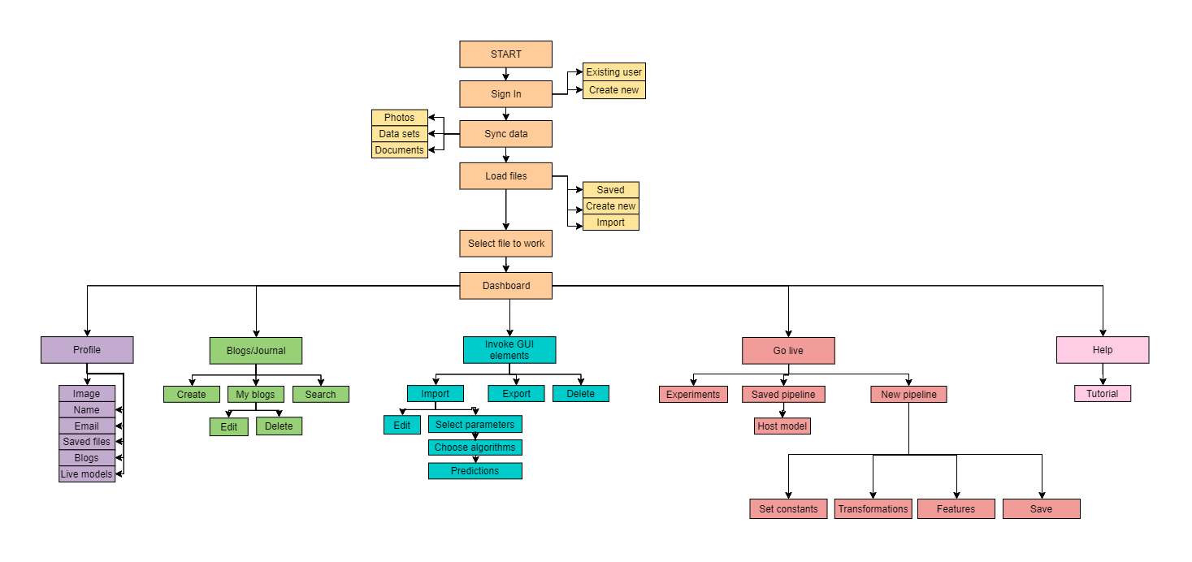

GUI

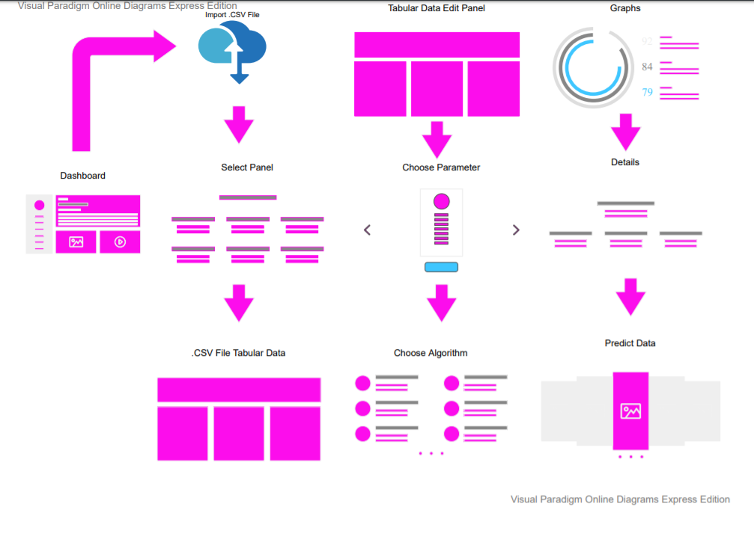

Project Plan

There will be six working Modules in our software Development Cycle named as follow:

* Start Module
* Profile Module
* Blogs/Journal Module
* Invoke GUI Module
* Go Live module
* Help Module

1. Start module

Firstly we’re going to start with the “Start module”. There will be many components in the start module as follow:

* Sign In
* Sync Data
* Load File
* Select File
* Dashboard

In “Sign In” , We’ve to ask the users if it is a “Existing user” or a “New User”. If HE/SHE will be a new user then we’ve to store their data in the database. Additionally, there will be “Photos, Datasets, Documents” option in “Sync data” Component, Similarly, “Save, Create and import” in the “Load file” component. Then, users have to select a file that They want to work upon. The approximate time to complete this section is 3 weeks.

1. Profile module

After the Start module we will be working on the “Profile module”. This module will be going to use for elicit user’s information like:

* Image
* Name
* Email
* Saved files
* Blogs
* Live models

This section will take 10- 15 days to complete.

1. Blog/Journal module

With the help of this module users can create its journals , and can edit previous , and can even search for the existing one.

This part of the project will required an estimated time of 3-4 weeks

1. Dashboard

It will be an Imperative Module. Vital parts of the software will be going to implement here.This module contains components like:

* Import
* Export
* Delete
* Algorithms
* Tabular data
* Visuals

CSV files will be imported , After parameters will be selected , then users will have to select the algorithm by which they want to predict the output.

This section will take the maximum 6 weeks to cover up.

1. Go Live

Several components will be accumulated here like:

* Experiments pipelines
* Saved pipelines
* New Pipelines

User created models and pipelines can be hosted on server and can accessed live using HTTP and REST protocols.

This section will require a relatively more number of weeks ranging 6-7 weeks.

6. Tutorial and user guide

List of important Tutorials and instructions for the user will be covered in the section:

* Guide to Creating Blogs
* Guide to creating pipeline
* Walkthrough the Dashboard Environment

This part will be covered in the last development phase and would require 7-10 days.